Nit

Q1.

input:-

Output -<html>

<head>

<title> Student Information </title>

</head>

<body>

<h4"> Basic Tags</h4>

</body>

</html>

Output:-



Q2.

Input -

html>

<head>

<title> Student Information </title>

</head>

<body <style="background-color:powderblue;">

<h4 style="background-color:violet;"> Student Name - Ashish Arora </h4>

</body>

</html>

output:-

Q3.

<html>

<head>

<title> Student Information </title>

</head>

<body style="background-color:powderblue;">

<h4 style="background-color:violet;"> Student Name - Ashish Arora

</h4>

<p> 1 </p>

<p> 2 </p>

<p> 3 </p>

<p> 4 </p>

<p> 5 </p>

<p> 6 </p>

<p> 7 </p>

<p> 8 </p>

<p> 9 </p>

<p> 10 </p>

</body>

</html>

Output -

Q4.

<html>

<head>

<title> Student Information </title>

</head>

<body style="background-color:powderblue;">

<h4 style="background-color:Tomato;"> Student Name - Pratham Sharma </h4>

<p style="color:red;"> 1 </p>

<p style="color:purple;"> 2 </p>

<p style="color:orange;"> 3 </p>

<p style="color:pink;"> 4 </p>

<p style="color:green;"> 5 </p>

<p style="color:blue;"> 6 </p>

<p style="color:brown;"> 7 </p>

<p style="color:yellow;"> 8 </p>

<p style="color:violet;"> 9 </p>

<p style="color:black;"> 10 </p>

</body>

</html>

Output -

Q5.

<html>

<head>

<title> Student Information </title>

</head>

<body style="background-color:powderblack;">

<h3 style="color:violet;"> Adding picture to background </h3>

<img src="https://encrypted-tbn0.gstatic.com/images?q=tbn:ANd9GcQEc9A_S6BPxCDRp5WjMFEfXrpCu1ya2OO-Lw&s">

</body>

</html>

Output-

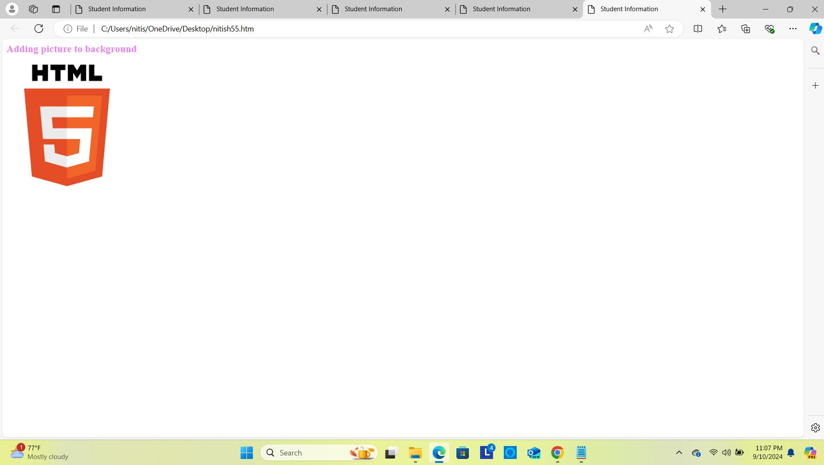

Q6.

<html>

<head>

<title> Student Information </title>

</head>

<body style="background-color:powderblue;">

<h5 style="Font-Family:Cursive;"> This is Paragraph one </h5>

<h4 style="Font-Family:Fantasy;"> This is Paragraph two </h4>

<h3 style="Font-Family:Helvetica;"> This is Paragraph three </h3>

<h2 style="Font-Family:Courier New;"> This is Paragraph four </h2>

<h1 style="Font-Family:Verdana New;"> This is Paragraph five</h1>

</body>

</html>

Output -

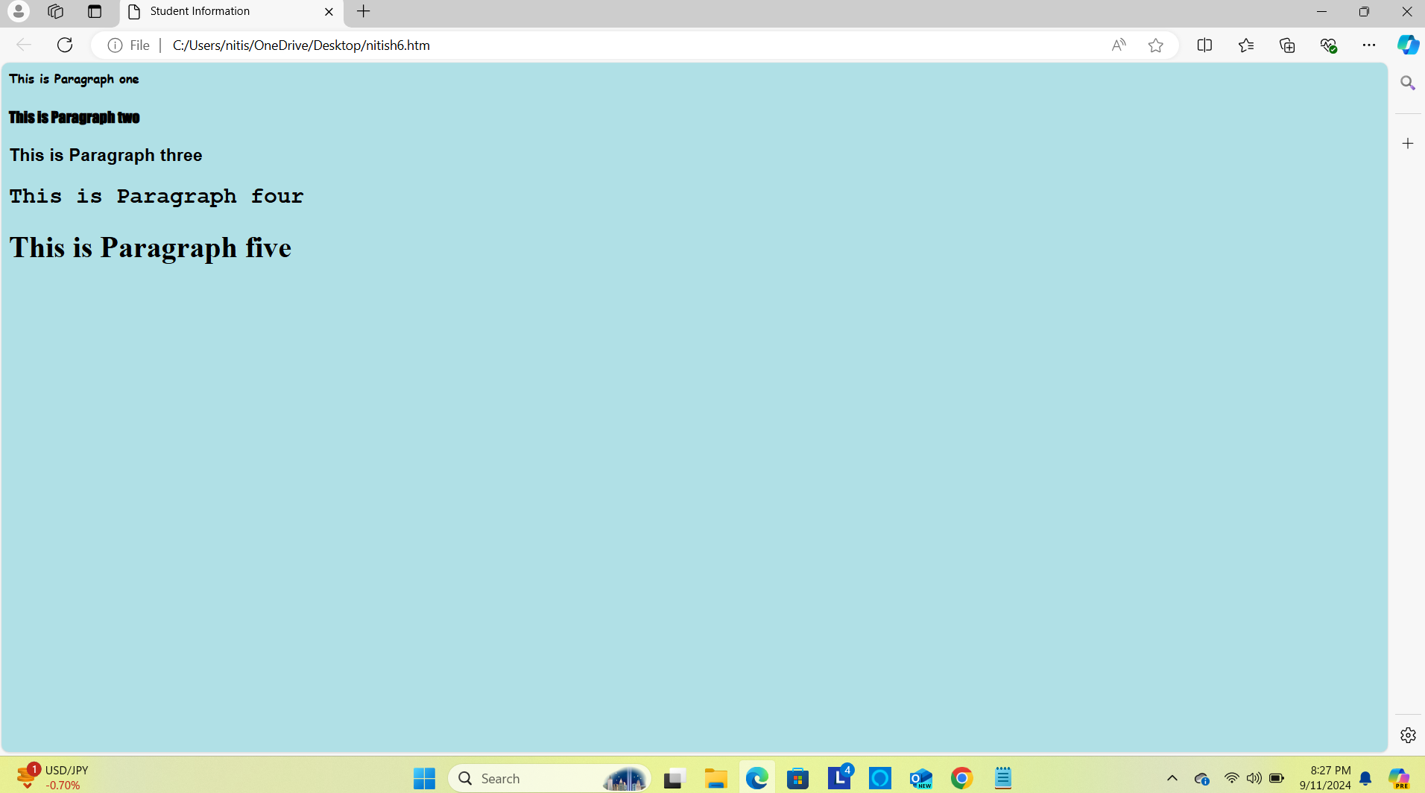

Q7.

<html>

<head>

<title> Student Information </title>

</head>

<body style="background-color:powderblue;">

<p>Book name - <b><u> Harry Potter and the Philosopher's Stone</b></u> Author name - <b><u>J. K. Rowling</b></u></p>

</body>

</html>

Output -

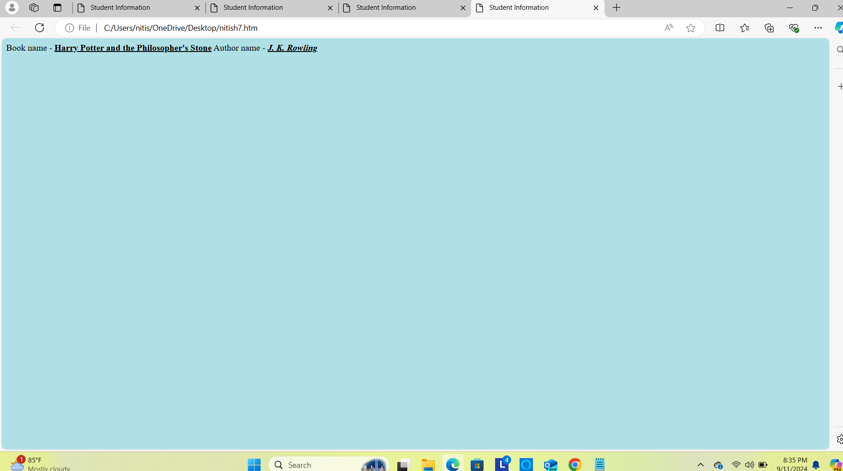

Q8.

<html>

<head>

<title> Heading Tag </title>

</head>

<body style="background-color:powderblue;">

<h1>N</h1>

<h2>I</h2>

<h3>T</h3>

<h4>I</h4>

<h5>S</h5>

<h1>H</h1>

</body>

</html>

Output -

Q9.

<html>

<head>

<title> Heading Tag </title>

</head>

<body style="background-color:powderblue;">

<p>1<sub>2</sub> = 2</p>

<p>2<sub>2</sub> = 4</p>

<p>3<sub>2</sub> = 6</p>

<p>4<sub>2</sub> = 8</p>

<p>5<sub>2</sub> = 10</p>

<p>6<sub>2</sub> = 12</p>

<p>7<sub>2</sub> = 14</p>

<p>8<sub>2</sub> = 16</p>

<p>9<sub>2</sub> = 18</p>

<p>10<sub>2</sub> = 20</p>

<p>11<sub>2</sub> = 22</p>

<p>12<sub>2</sub> = 24</p>

<p>13<sub>2</sub> = 26</p>

<p>14<sub>2</sub> = 28</p>

<p>15<sub>2</sub> = 30</p>

<p>16<sub>2</sub> = 32</p>

<p>17<sub>2</sub> = 34</p>

<p>18<sub>2</sub> = 36</p>

<p>19<sub>2</sub> = 38</p>

<p>20<sub>2</sub> = 40</p>

</body>

</html>

Output -

